Introduction to Neural Networks and Deep Learning

Syllabus

1. Introduction to Deep Learning
   1. Introduction to Deep Learning
   2. Biological Neural Networks and Deep Learning
   3. Artifiicial Neural Networks – Forward Propagation
2. Artificial Neural Networks
   1. Gradient Descent
   2. Backpropagation
   3. Vanishing Gradient
   4. Activation Functions
3. Deep Learning Librabries
   1. Introduction to deep learning libraries
   2. Regression models with Keras
   3. Classification Models with Kera
4. Deep Learning Models
   1. Shallow and Deep Neural Networks+
   2. Convolutional Neural Networks
   3. Recurrent Neural Networks
   4. Autoencoders

**Deep Learning with Keras**

Applications with DL

* Color restoration
* Speech Reenactment
* Handwriting
* Automatic Machine translation
* Object classification

Neurons and Neural Networks

Many algorithms in DL are inspired by the way neurons and neural network’s function.

Artificial Neurons behave in the same way as biological neurons

Artificial Neurall Networks

Consist of layers

* Input layer
* Output layer
* Hidden layers

Main topics

* Forward propagation
* Backward propagation
* Activation Functions

Forward propagation

The process of data pass through layer of neurons in a neural network from input to output

Normally represented as x1 * w1 + xn * wn + b1 = a = z

Where x represents the input value and w represents the weighting or coefficient and b represents the bias (a constant), z is the combination of weioghts, coefficients and bias, and a is the output of the network. NB. When using multiple layers, the output from the previous layers neuron is the input for the current layer.

Simply outputting a weighted sum of inputs is limiting. So the sum is normally mapped to a nonlinear space often using the sigmoid function.

$$a=f(z)=\frac{1}{{1+e}^{-z}}$$

Nonlinear functions like sigma are called **activation functions.** They (more or less) decide whether a neuron should be active or not based on the relevance of the information being received.

A neural network without an activation function is ostensibly just a linear regression model.

**Gradient Descent**

Cost Function

$$J\left(w\right)=\frac{1}{2m}\sum_{i=1}^{m}{({z_{i}-{wx}_{i})}^{2}}$$

To decide in which direction to move (which side of the curve are we on? Is pos or neg?) we use the slope of the tangent at $w_{0}$ or:

$$\frac{δj}{δw}$$

The magnitude of the movement along is determined by the learning rate.

$$η=Learning rate$$

Higher the learning rate the bigger the step in the cost function

So

$$w^{1}→w^{0}-\frac{δj}{δw}$$

Process is repeated using same learning rate until minimum is hit (or as close as)

Nb. Large and small steps have positives and negatives. Ie speed vs. accuracy.

The goal of the algorithm in the neural network is to minimize the loss function by updating the weights of the network iteratively. The objective then is to find the set of weights that results in the lowest possible value of the loss function. What this is indicates is how accurate the model predicts the target values.

Several algorithms are commonly used variations of the basic gradient descent algorithm to enhance its performance and address some of its limitations. Some of the most widely used gradient descent algorithms include:

1. **Batch Gradient Descent**: This is the standard form of gradient descent. In each iteration, the algorithm computes the gradient using the entire training dataset. It can be slow for large datasets but can converge to a global minimum if the loss function is convex.
2. **Stochastic Gradient Descent (SGD)**: In each iteration, SGD randomly selects a single training example and computes the gradient based on that example. It can be much faster than batch gradient descent and can escape local minima more easily. However, its updates can be noisy, and the convergence can be erratic.
3. **Mini-Batch Gradient Descent**: This is a compromise between batch gradient descent and SGD. In each iteration, a small random subset (mini-batch) of the training data is used to compute the gradient. This combines some of the benefits of both batch and stochastic approaches.
4. **Gradient Descent with Momentum**: This algorithm uses an exponentially decaying moving average of past gradients to accelerate convergence, especially in directions with consistent gradients. It helps overcome oscillations and speeds up convergence.
5. **Adaptive Learning Rate Methods**:
   * **Adagrad**: Adapts the learning rate individually for each parameter by dividing the learning rate by the square root of the sum of squared gradients.
   * **RMSProp**: Similar to Adagrad but with a decaying average of squared gradients, preventing the learning rate from getting too small.
   * **Adam (Adaptive Moment Estimation)**: Combines momentum and adaptive learning rates. It maintains moving averages of both gradients and squared gradients and adjusts the learning rate accordingly.
6. **Nesterov Accelerated Gradient (NAG)**: This is an improvement upon the standard momentum approach. It adjusts the momentum term to take into account a "lookahead" gradient computed at a slightly ahead position, resulting in faster convergence.
7. **Rprop (Resilient Propagation)**: Updates the learning rates based on the sign of the gradient. If the gradient keeps the same sign, the learning rate increases; if it changes sign, the learning rate decreases.
8. **Adaptive Subgradient Methods**:
   * **AdaGrad**: Adapts the learning rate for each parameter based on the magnitude of historical gradients.
   * **Adadelta**: An extension of AdaGrad that addresses the issue of diminishing learning rates by using a running average of squared parameter updates.

These are just a few of the many variations and improvements to the basic gradient descent algorithm. The choice of algorithm depends on factors like the problem, the size of the dataset, the network architecture, and desired convergence properties.

**Back Propagation**

How do models optimize weights and biases?

Model training is done in a supervised setting where each data point has a label or ‘ground truth’ (T)

Training is needed when the predicted value != ground truth

The training process follows these steps.

1. Calculate the error (E) between the ground truth and the output. This error represents the cost/loss function.
2. The error is then propagated back into the network and each weight and bias is updated per the gradient descent equations, ie:

$$w_{i},→w_{i}-η\frac{δE}{{δw}_{i}}$$

$$b_{i},→b_{i}-η\frac{δE}{{δb}_{i}}$$

The error is calculated using mean squared error, then propagated back into the network.

For example, in a network with 2 nodes and paths (b1, w1, b2, w2) to update w2 the gradient descent equation is used. However E is not explicitly a function of w2, the chain rule must be used to establish the derivative of the error with respect to w2.

E is a function of a2

$$E=\frac{1}{2}(T-{a_{2})}^{2}$$

A2 is a function of z2

$$a=f(z)=\frac{1}{{1+e}^{-z}}$$

And z2 is a function of w2

$$z_{2}=a_{1}*w_{2}+b_{2}$$

Therefore, we can take the derivative of E with respect to a2

$$\frac{δE}{{δa}_{2}}$$

The derivative of a2 with respect to z2

$$\frac{{δa}_{2}}{{δz}_{2}}$$

And the derivative of z2 with respect to w2

$$\frac{{δz}_{2}}{{δw}_{2}}$$

Then the derivative of the error with respect to w2 would be the product of these individual derivatives.

$$\frac{δE}{{δw}_{2}}= \frac{δE}{{δa}_{2}}* \frac{{δa}_{2}}{{δz}_{2}}* \frac{{δz}_{2}}{{δw}_{2}}$$

**What is chain rule?**

The chain rule states that the derivative of a composite function (a function formed by applying a function to the output of another function) is the product of the derivatives of the component functions ie:

If we have 2 function f and g that combine to function h:

$$h\left(x\right)=f(g\left(x\right))$$

then (using Leibniz notation)

$$\frac{dh}{dx}= \frac{df}{dg}* \frac{dg}{dx}$$

To summarize

1. Init weights and biases
2. Calculate network output using forward propacgation
3. Calculate error between ground truth and estimated or predicted output
4. Update weights and biases through back propagation
5. Repeat steps 2 – 4 until a number of iterations/epochs are reached or error between ground truth and predicted out is below a predefined threshold.

**Vanishing Gradient**

A problem with the sigmoid activation function.

The size of the error with respect to w1 is incredibly small.

This is because factors of less than one (due to the sigmoid activation) are multiplied repeadetdly resulting in smaller and smaller.

This means neurons at the earlier layers decrease to the lowest error more slowly than the later layers and some too slowly to make the model usable.

So the sigmoid function is not used for activation.

**Activation Functions**

The functions that are now used

Types:

1. Binary Step Function
2. Linear Function
3. Sigmoid Function
4. Hyperbolic Tangent Function
5. ReLu (Rectified Lienear Unit)
6. Leaky ReLu
7. Softmax Function

Of these, 4 are most commonly used:

* + The sigmoid
  + Hyperbolic Tangent Function
  + ReLu
  + Softmax

**Sigmoid Function**

$$a=\frac{1}{1+exp(-z)}$$

At z = 0 x = 0.5

When z is large positive number a is close to 1 and vice versa

The function is however normally flat beyond +3 and -3

This means that once the function enter these regions, the gradients become very small

Resulting in the vanishing

gradient problem.

Similar the values received are always positive and not symmetric around the origin.

By scaling the sigmoid function, this problem can be avoided, resulting in the hyperbolic tangent function.

**Hyperbolic Tangent Function**

$$a= \frac{exp\left(z\right)-exp(-z)}{exp\left(z\right)+exp(-z)}$$

Simialar to the sigmoid function, it is however symmetrical round the origin and the values range from -1 to 1.

It also however leads to the vanishing gradient problem in very deep neural networks

**Rectified Linear Unit ReLu**

The most widely used activation function

$$a=max⁡(0,z)$$

Its nonlinear, it doesn’t activate all neurons at the same time.

If the input is negitave the output is converted to 0 and the neuron is not activated.

This means that only a few neurons are active at any one time making the network very efficient.

It does not suffer from the vanishing gradient.

**Softmax Function**

$$a_{i}=\frac{e^{z_{i}}}{\sum_{k=1}^{m}{e^{z_{k}}}}$$

Useful for classification problems.

Ideally used in the output layer of the classifier to find the probability of each output.

Eg for a vector of outputs.

$$z= \begin{matrix}z_{1} \\ z_{2} \\ z_{3}\end{matrix}= \begin{matrix}1.6 \\ 0.55 \\ 0.98\end{matrix} \underset{→}{softmax}\begin{matrix}0.51 \\ 0.18 \\ 0.31\end{matrix}$$

In summary, the sigmoid and hyperbolics tangent function are avoided in most applications due to the vanishing gradient problem. Instead ReLu is the function that is most often used BUT only in the hidden layers.

Popular Deeplearning Librabries and Frameworks

1. Tensorflow (google)
2. Keras (also google)
3. PyTorch (Version of the Lua-based torch framework) supports machine learning algorithms running on GPUs in particular.
4. Theano (No longer supported)

Both pytorch and tensorflow have a steep learning curve. Keras has apparently the easiest API and go-to library for quick prototyping and fast development times.

It’s a high-level API.

Keras runs on top of a high level library like tensorflow.

**Regression Models with Keras**

**Shallow vs. Deep Neural Networks**

The difference between shallow and deep neural networks has no consensus, generally:

* + A shallow network consists of one hidden layer
  + A deep network consists of multiple hidden layers with a large number of neurons per layer
  + Most importantly, a shallow neural network can only take information inputs in the form of vectors whereas a deep learning model can accept raw data as an input such as images and text, and automatically extract the necessary features.

Why has this recently happened?

Can be attributed to 3 main factors:

1. Advancement in the field – the relu activation function helped overcome the diminishing gradient problem.
2. Data – Data availability specifically large amounts has recently become available and helps immensely with overfitting of models. Generally with machine learning the model learns to a certain point and then more data does not help the model, whereas in deep learning more data equates to better performance.
3. Computational Power – notably nvidia gpus

**RELU Explained**

Stands for Rectified Linear Unit. Defined asÖ

$$f\left(x\right)=max⁡(0,x)$$

Ie.

If x is positive, it returns x.

If x is zero or negative, it returns 0

X refers to the input to the function typically the weighted sum of inputs to a neuron before activation is applied.

The input value is not automatically normalized, and is instead usually passed through the function as is. However normalization or scaling of input data is a common preprocessing step as this helps the optimization process converge more quickly.

**Normalization**

Several methods of normalization can be used.

* + Min-Minx Scaling: Scales the data to lie between a given minimum and maximum value, normally 0 and 1.
  + Standard Scaling (Z-Score normalization): Scales the data based on the mean and std dev, resulting in data with a mean of zero and a standard deviation of 1.
  + Batch Normalization: Used within neural networks where during traing the activation of a given lazer are normalized for each mini-batch. Can imporve training speed and reduce sensitivity to initialization of weights.

Typically, though the data is not manually normalized. Instead mechanisms like batch normalization are used to address the interal normalization within the network layers.

**RELU Advantages**

* + Computational simplicity
  + Mitigates the vanishing gradient problem

**Relu Disadvantages**

* + Dying ReLU Problem – If a neuron outputs a negative value, it will get stuck and won’t activate during training, essentially becoming useless. This means no updates occur during backpropagation.
  + Not zero centered – ReLU outputs are always non-negative, which can sometimes lead to undesirable outcomes during training.

To handle these challenges other variations of ReLU can be used:

* + Leaky ReLU – Allows for small, non-zero gradient for negative values.

Defined as:

$$f\left(x\right)=max⁡(α*x,x)$$

This function returns x if it receives a positive value but a small weighted value if x is negative. Alpha is normally set to 0.01.

* + Pametric ReLU – Similar to Leaky ReLU but alpha is learned during training rather than predefined
  + Exponetial Linear Unit (ELU) – Tries to make average outputs closer to zero, helping with training dynamics.

**Convolutional Neural Networks (CNNS)**

Deep Learning Algorithms (Supervised)

* + Like typical neural networks
  + CNNs take images as inputs
  + This allows the incorporation of properties that make training more efficient
  + They solve problems of image recognition, object detection and other computer vision problems.

They are made up of neurons which need to have their weights and biases optimized. Each neuron combines the inputs it receives by combing the dot product of all weights and biases before feeding the resulting input into an activation function, most likely ReLU.

They differ from typical neural networks in that the explicitly expect an image as input. This allows for certain properties to be built into their architecture thus reducing the amount of params in the network and increasing efficiency.

The typical architecture of a convolutional neural network would be:

Input Img -> Convolution Layer -> Pooling Layer -> Convolution Layer -> Pooling Layer -> Fully Connected Layer -> Output

**Input Layer**

While a normal input for a neural network is a vector of the dimension n*1

For a convolutional Model this would be m * n * 1 (an black and white image) or m * n * 3 (coloured image, rgb)

**Convolutional Layer**

Defines filters and computes convolution between the defined filters and each of the 3 imgs.

Convolution helps the model detect patterns edges and features within input data.

The process can be simplified to:

1. **Convolutional Operation:** for an input matrix (img) and a smaller filter (n*m*1, also called the kernel or convolutional kernel), the filter slides (convolves) across the input matrix.
2. **Element-wise Multiplication and Summation:** At each position where the filter is placed , a element-wise multiplication between the filter and the portion of the input that is covered is performed and then summed (dot product) to obtain a value.
3. **Resulting Feature Map:** The output of this summation is placed in a new matrix known as the *feature map.* The feature map highlights patterns or feature that the filter is designed to detect.
4. **Stride and Padding:** The parameters that control convolution are stride and padding. Stride is the iterative step the filter moves between each convolution operation and padding controls the size of the output feature map.
5. **Multiple Filters:** Practically CNNs use multiple filters on each convolutional layer with each filter detecting different patterns and features. This results in a set of feature maps that capture different features.
6. **Activation Function:** After convolution, an activation function such as ReLU is applied to introduce non-linearity and help the network learn more complex patterns. This application of a non-linear function transforms the output of a linear operation (weighted sum of inputs)

These layers are stacked together in a CNN and as the layers get deeper, increasingly abstract features can be learned, making the technique ideal for image recognitions, object detection and image segmentation.

Why use convolution? Why not flatten the img into an n*m*1 vector? This increases the amount of parameters and consequently the cost of computation.

**Pooling Layer**

The pooling layers main function is to reduce the special dimensions of the data that propagate through the network. (producing the matrix)

There are two types of pooling widely used:

* + Max pooling – most commonly used. Keeps the highest value of the kernel for the new matrix.
  + Average Pooling – takes an average value of each scanned area.

Pooling (Max Pooling) also provides spatial variance which lets the recognize objects even if the object does not fully resemble the original object.

**Fully Connected Layer**

Flattens the output of the last convolutional layer and connect all nodes of the current layer with the nodes of the next. It accepts the output of the preceeding layer whether convolutional or pooling or relu. It outputs an n-dimensional vector where n is the number classes pertaining to the problem. Ie. If the model was detecting digits the value of n would be 10 as the are 10 digits (0-9).

**Keras Overview for CNN Model**

Model=Sequential()

**PDF Graph Identifier**

Applying this to a real-world example, like detecting graphs in PDFs (😊) here is a rough approach:

1. PDF to Img conversion: The PDF would be converted to an image format (JPG or PNG).
2. Object Detection: Using a trained CNN-Based object dection model to detect graphs in the converted images. There are many established architectures and frameworks for object detection such as:
   1. YOLO (You only look once): A real-time object detection system.
   2. SSD (Single Shot Multibox Detector): Another Realtime detection system.
   3. Faster R-CNN: A region based detector with a more complex pipeline that YOLO or SSD but considered more accurate.

A labelled dataset of images with graphs to train such models would be needed or fine-tuning of a preexisting dataset if it existed.

1. Post-processing: Once the graphs are detected, post-processing steps can be applied depending on the requirements, such as extracting the graph region for further analysis, annotation etc..
2. Fine-Tuning and Iteration: Dependent on the variety and complexity of PDFs further refinement may be necessary.

Success would ultimately be dependent on the quality and quantity of the training data, the specificity of the grpahs to be detected and the potential presence of any other visual elements.

**Recurrent Neural Networks**

Neural Networks usually see datapoints as independent instances however for problems such as moving images, data between different observations cannot be assumed to be independent. Traditional models are not suitable for this. RNNs have loops that don’t just take in new inputs but also the previous output of the datapoint that was fed into the network.

Great for things such as text, genomes and STOCK MARKETS!!!!! They take time and and sequence into account, meaning they have a temporal dimension

The architecture looks like:

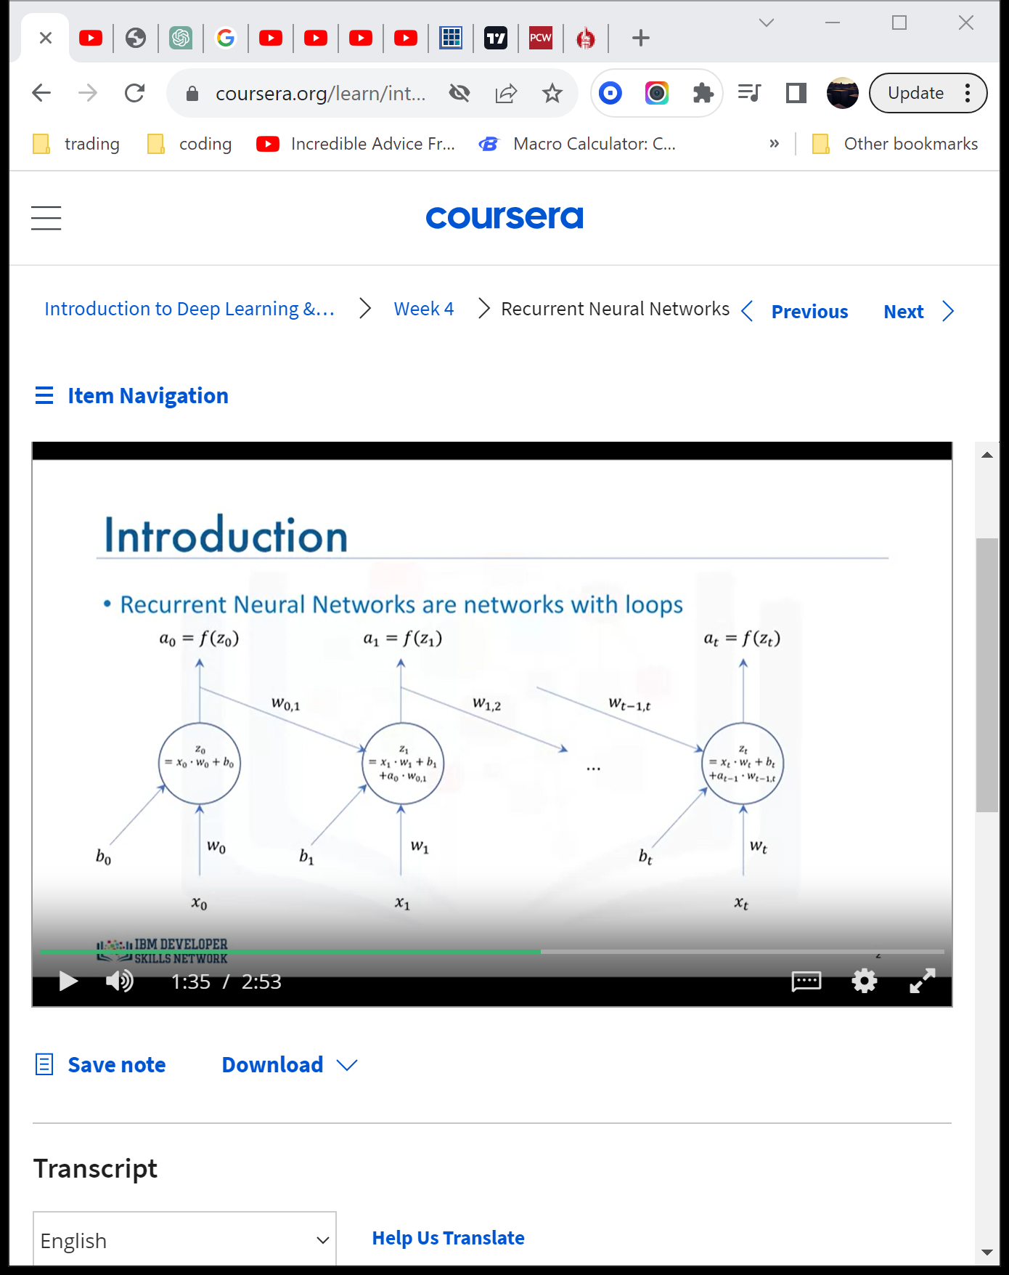

A popular RNN is the Long Short-Term Memory Model (LSTM)

Applications include:

1. Img Generation
2. Handwriting Generation
3. Automatic Captioning of Images
4. Automatic Description of Videos

Autoencoders

Both the CNN and RNN are supervised learning models. The autoencoder model is unsupervised.

* + Autoencoding is a data compression algorithm where the compression and decompression functions are learned automatically from the data itself.
  + Autoencoders are data-specific ie. They can only compress data similar to what they are trained on. Aka a model designed to compress data for cars will not be able to, or at least not do a good job at compressing data for pictures of houses.
  + Applications include data denoising and dimensionality reduction for data visualization.

The algorithm follows the pattern:

Input -> encoder -> compressed representation of input -> decoder -> output (hopefully the same as input)

* + The autoencoder is an unsupervised neural network model.
  + It tries to predict x from x without the need for any labels.
  + Because of nonlinear activation functions autoencoders can learn data projections that are more interesting than PCA (Principle component analysis) or other basic techniques.

A popular type of autoencoder is the Restricted Boltzmann Machine (RBM). They are typically used for:

* + Fixing imbalanced datasets
  + Estimate Missing Values in a dataset
  + **Automatic feature extraction of unstructured data.**